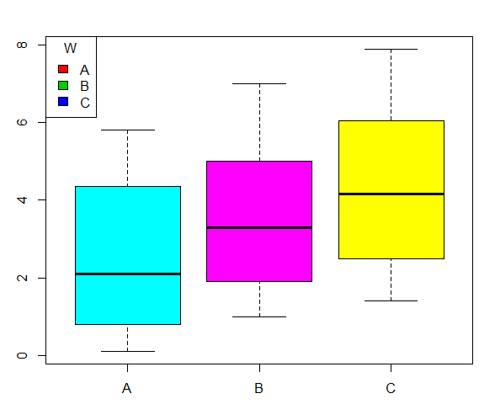

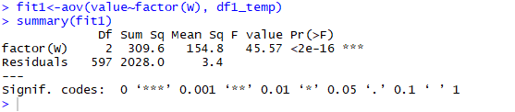

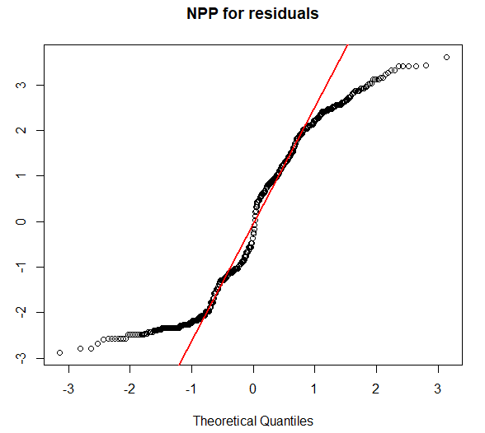

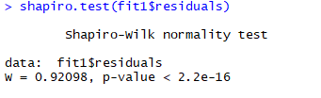

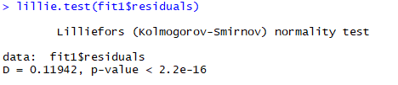

The residual are not normally distributed.

As alternatives, I would either transform the data to approach normality or use non-parametric methods (Kruskal-Wallis)

There is no use to proceed with homoscedasticity check since it requires normally distributed residuals.

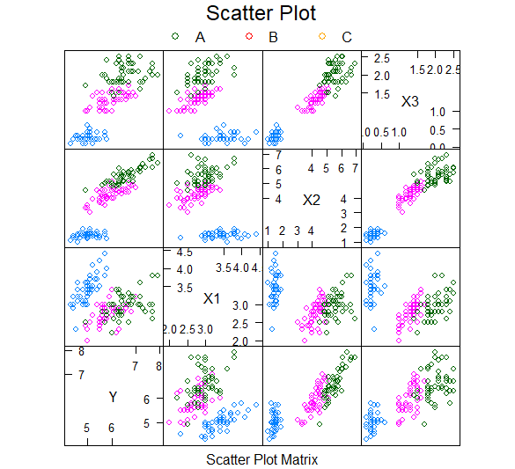

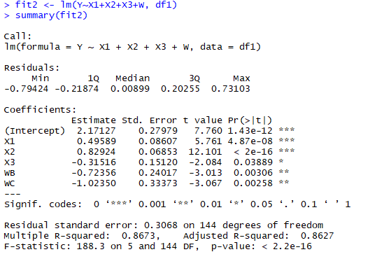

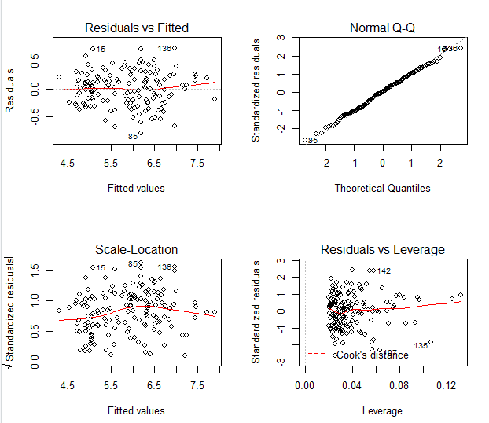

According to the plots, the assumptions are true. The residuals are normally distributed and they seem to have equal variances.

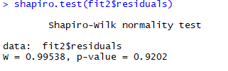

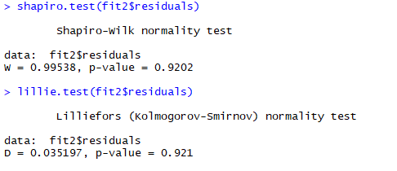

p-values are significantly high so we can't reject the normality of the residuals

A possible alternative if the assumptions weren't true, would be to use the logY.

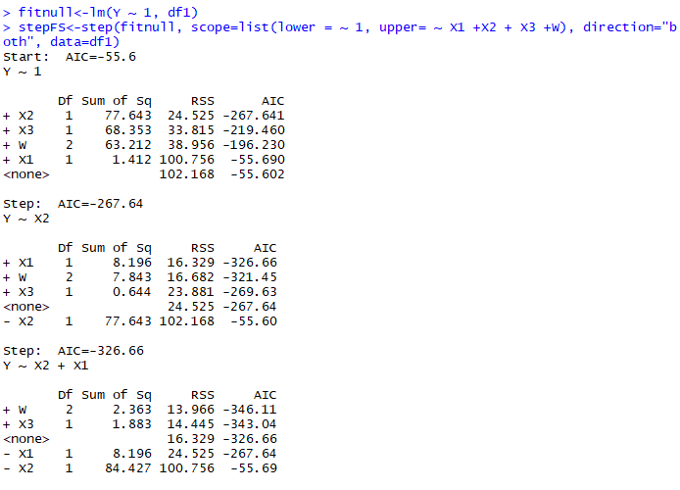

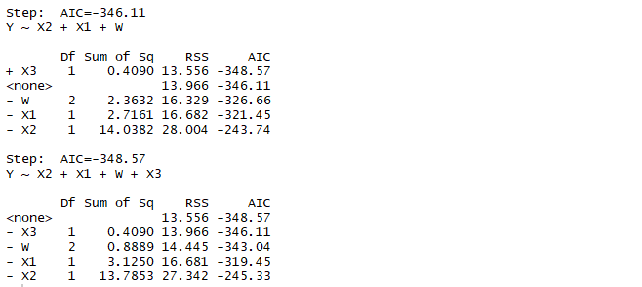

The stepwise regression shows that the model cannot be reduced further.

Same with all subsets regression.

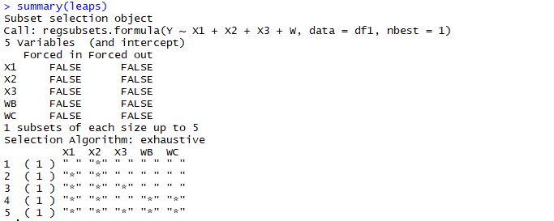

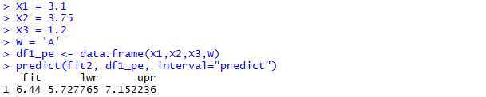

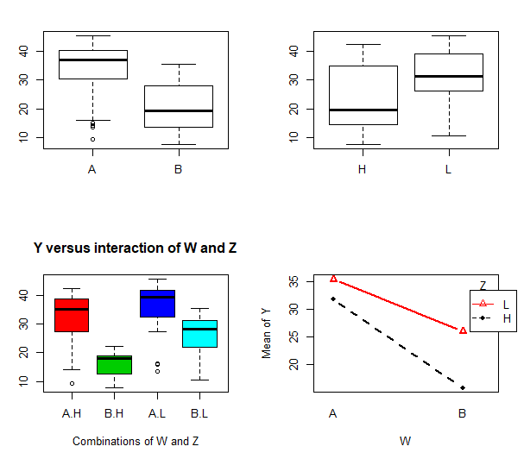

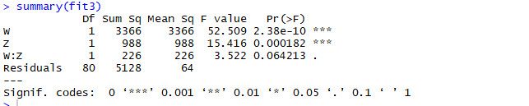

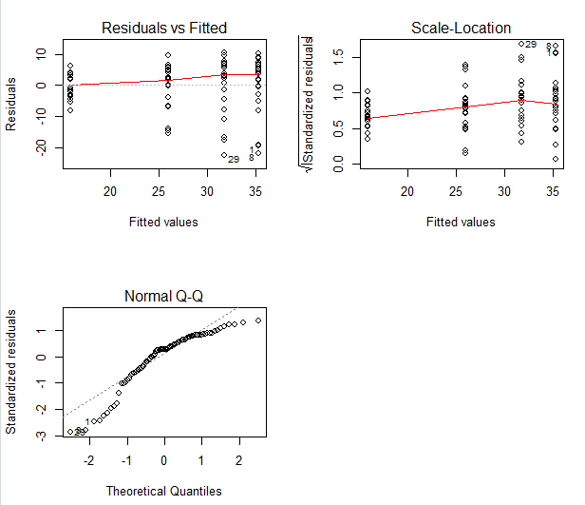

According to the plots, it is obvious that the residuals are not normally distributed so the Anova results cannot be trusted.